**EX NO:4b DATE:22.03.2025**

**NAME:S.Subramanian**

**ROLL NO:230701349**

**Conduct task analysis for an app (e.g., online shopping) and document user flows. Create corresponding wireframes using dia**

**AIM:**

The aim is to perform task analysis for an app, such as online shopping, document user flows, and create corresponding wireframes using Dia.

**PROCEDURE:**

**Tool link:** <http://dia-installer.de/>

1. Install Dia:
   * Download Dia from the official website (<http://dia-installer.de/>)
   * Install Dia on your computer
   * Open Dia:
   * Launch the Dia application.
2. Create New Diagram:
   * Go to File -> New Diagram.
   * Select Flowchart as the diagram type.
3. Add Shapes:
   * Use the shape tools (rectangles, ellipses, etc.) to create wireframes for each screen.
     + For example:
       - Home Page: Rectangle
       - Product Categories: Rectangle
       - Product Listings: Rectangle
       - Product Details: Rectangle
       - Cart: Rectangle
       - Checkout: Rectangle
       - Order Confirmation: Rectangle
       - Order History: Rectangle
4. Connect Shapes:
   * Use the line tool to connect shapes, representing the user flows.
     + For example:
       - Home Page -> Product Categories
       - Product Categories -> Product Listings
       - Product Listings -> Product Details
       - Product Details -> Cart
       - Cart -> Checkout
       - Checkout -> Order Confirmation
       - Order Confirmation -> Order History
5. Label Shapes:
   * Double-click on each shape to add labels.
     + For example:
       - Label the rectangle as "Home Page", "Categories", "Product Listings", "Product Details", "Cart", "Checkout", "Order Confirmation", "Order History".
6. Save the Diagram:
   * Go to File -> Save As.
   * Save the diagram with a meaningful name, such as "Online Shopping App User Flows".

**OUTPUT:**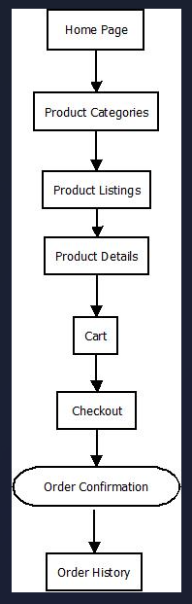

**RESULT:**Conducting task analysis for an app and creating userflows using dia has been executed successfully.